|  |  |  |  |  |  |
| --- | --- | --- | --- | --- | --- |
| Date | 11-Dec-22 | | | Tester Name | Mohammad Yusuf |
| Environment | Penfax - Test | | | Login used |  |
| Operating System | Windows | Version: | Update: | | |
| Software Used | Edge | Version: | Update: | | |
| Not Applicable | Version: | Update: | | |
| Release version |  | | | | |
| Title | E6 Contributions | | | | |
| Test Type | Regression | | | | |
| Test Scenario | E6.01 Post EEID Contribution manually | | | | |
|  |  | | | | |
| Expected Results | Contribution amount should be available under Contribution History, Payroll History and Account Activity.  Contribution amount should be included in PEPP Valuation Report by employer name and the funds. | | | | |
| Pass/Fail | Pass | | | JIRA# | N/A |

Describe your steps with screenshots:

1. Log into Employer PLANet (DCT) and select an employer from the dropdown for whose employees you want to process the contribution.

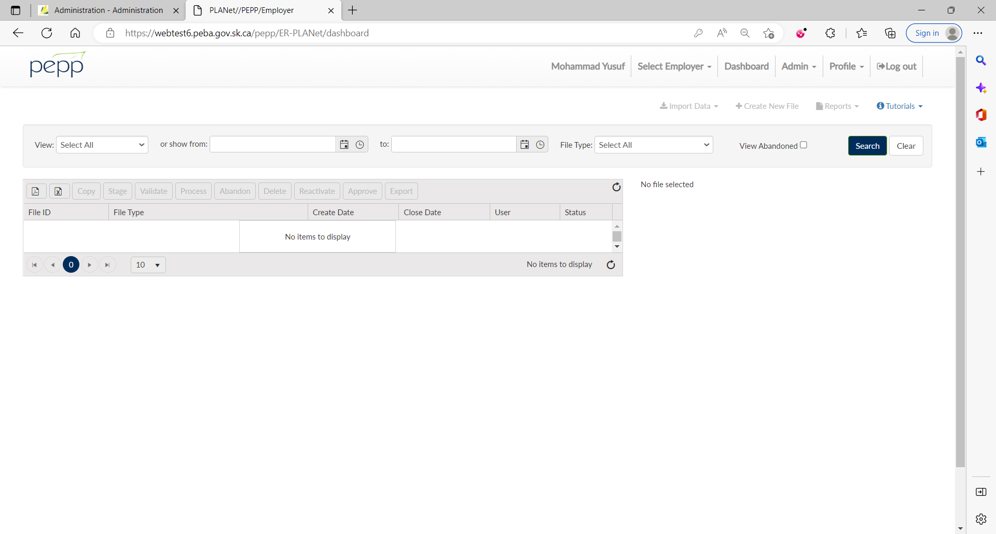

1. Click Create New File.

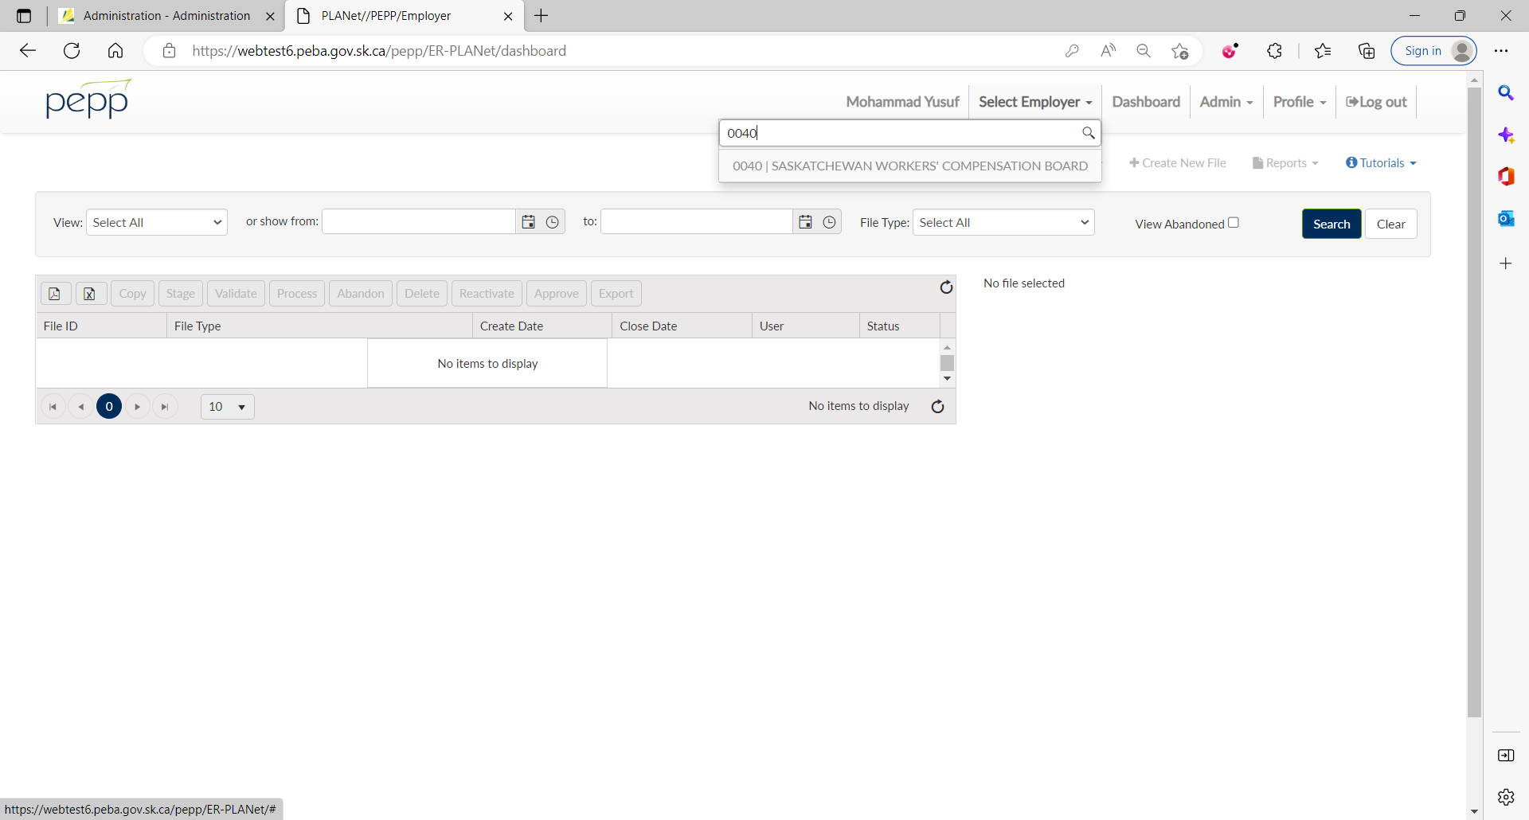

1. From the dropdown, select Contribution (EEID Format) to upload a contribution via EEID.

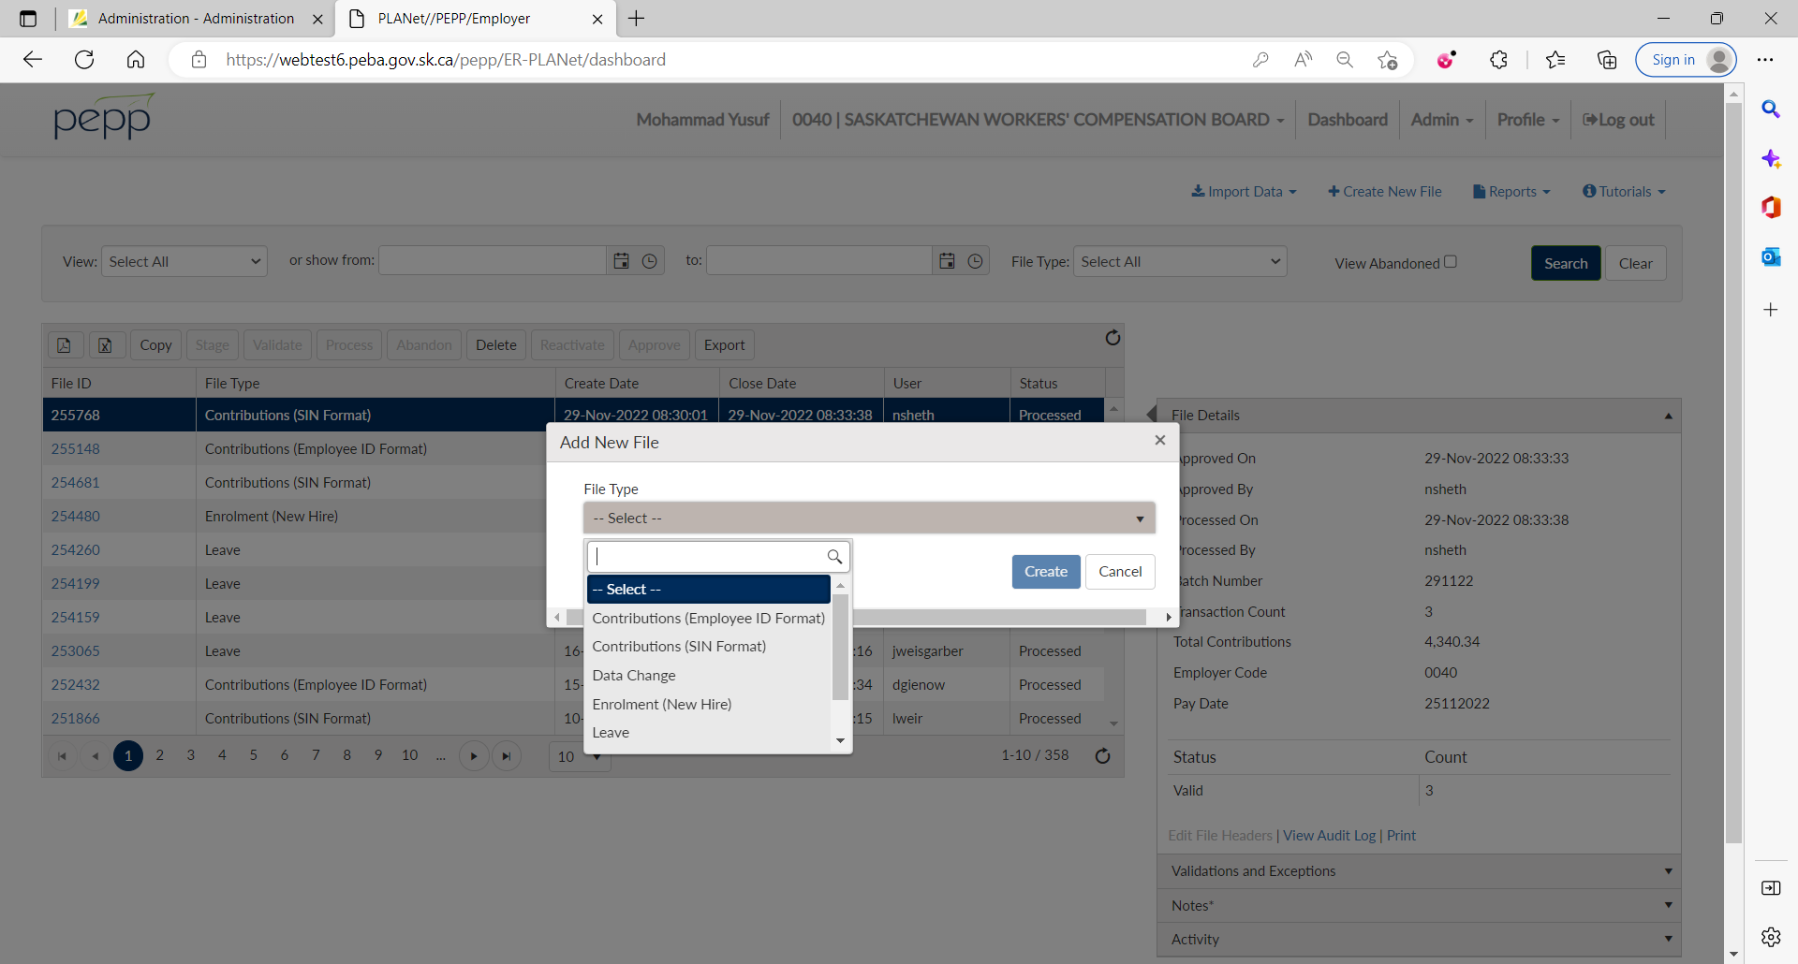

1. Enter Batch Number and Pay Date and click on Create.

Batch Number should be in DDMM## format where DD is 01-31, MM 01-12 and ## is any 2 digits or 2 characters or a combination of a digit and a character.

Pay Date should be in DDMMYYYY format.

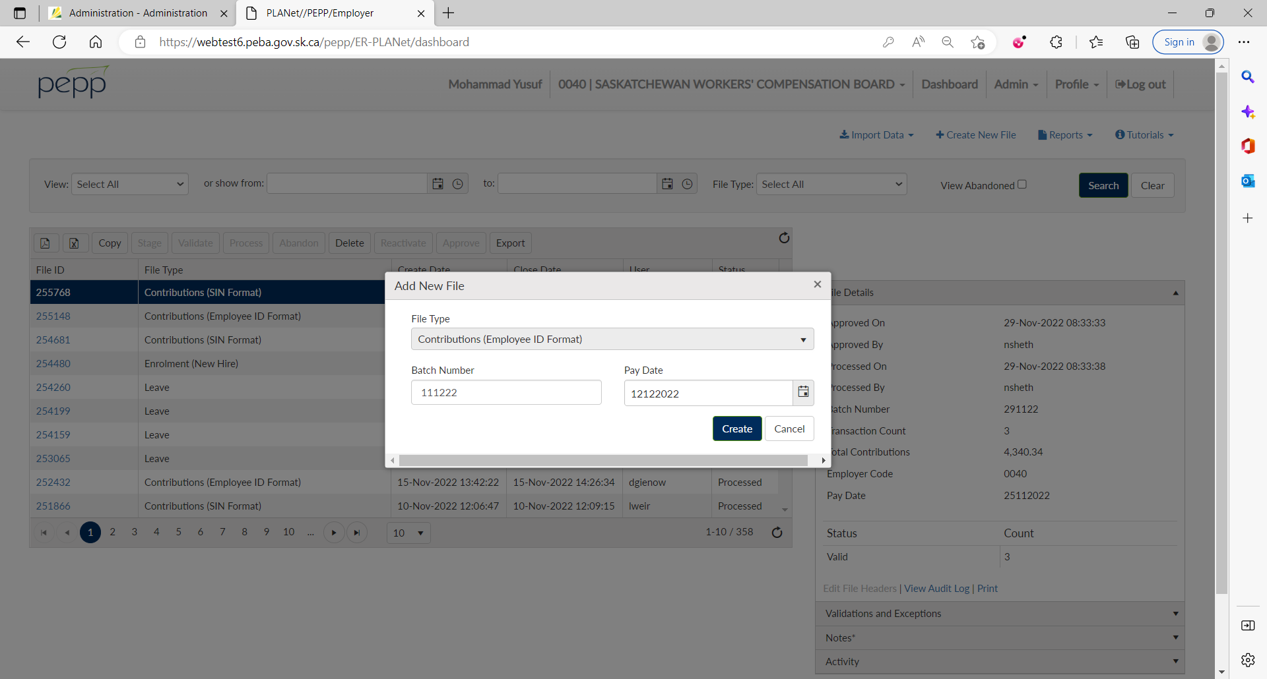

1. Click on File ID.

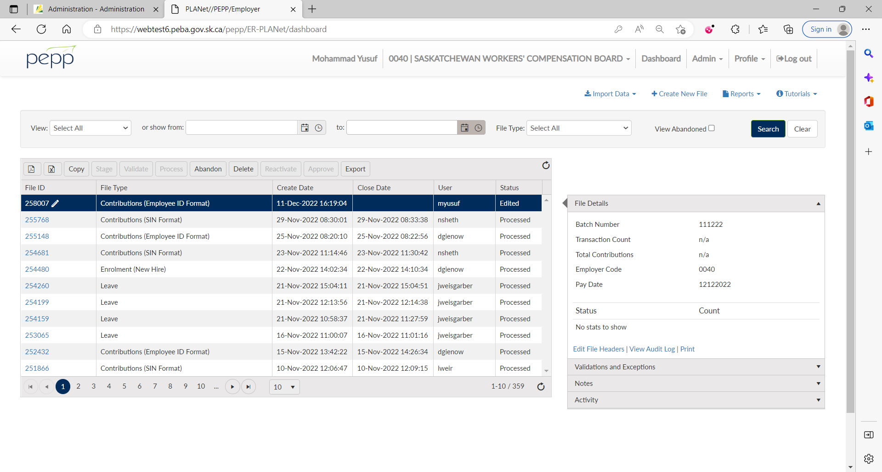

1. Click Add.

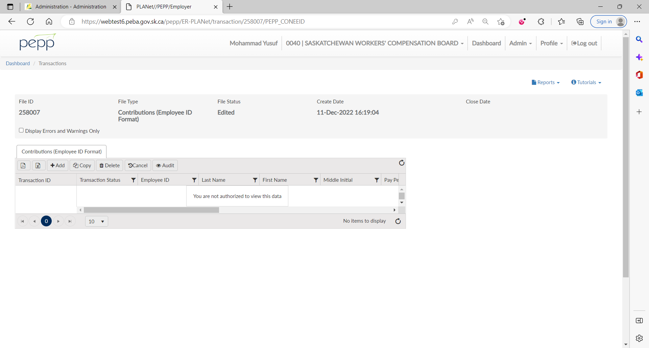

1. Enter employee’s details including contributions and save. Repeat step 6 and 7 for each of the employees.

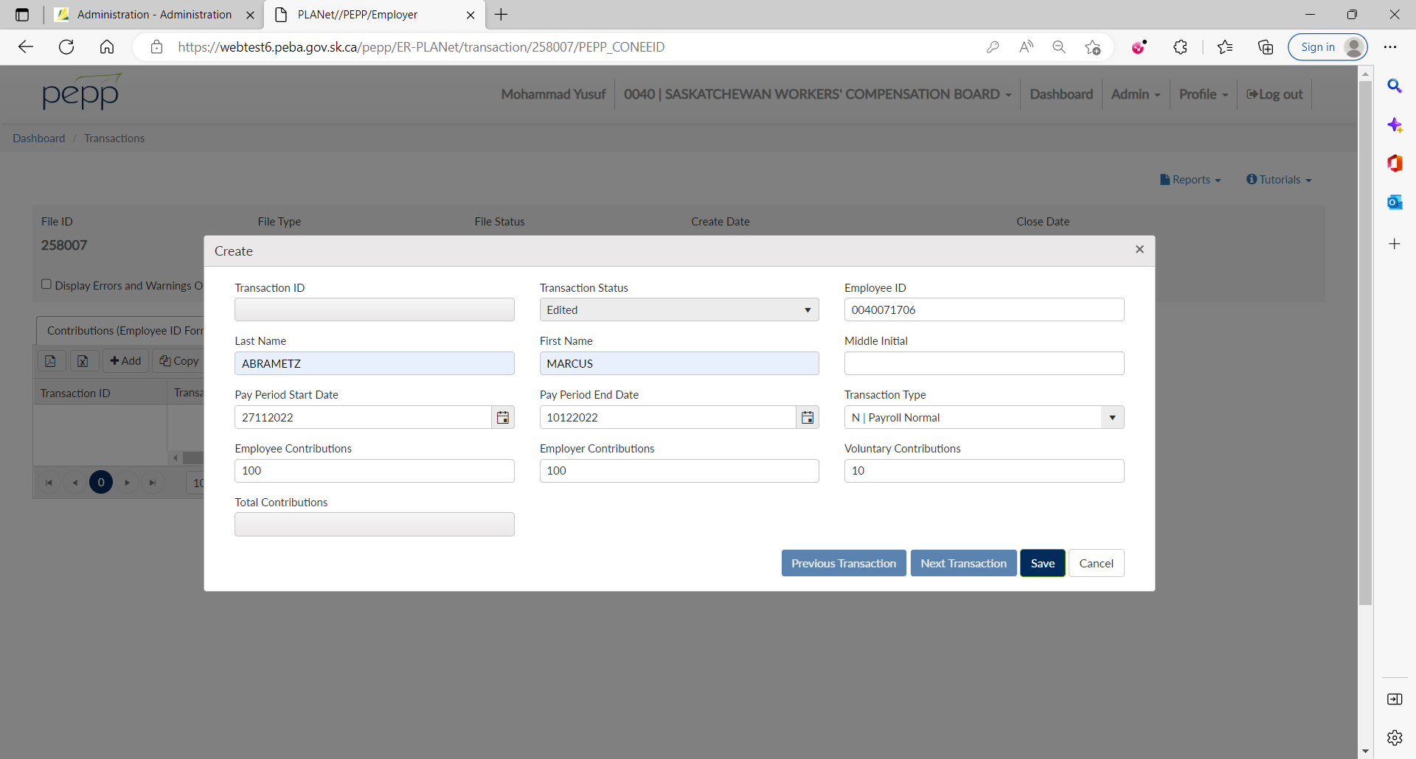

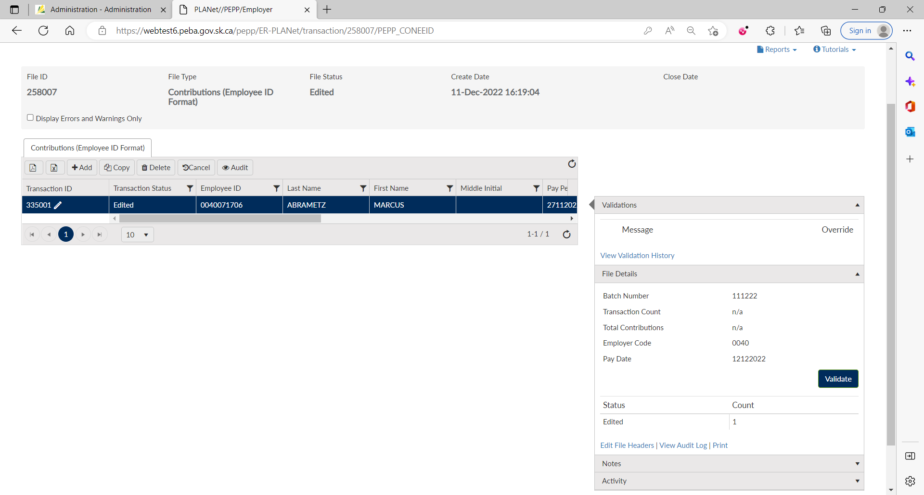

1. Under File Details, click on Validate.
2. You can now see Transaction Count and Total Contributions as it has been validated. Click on Approve.
3. Validation triggered is Info. so no need to override it. Employer can confirm once on their end.

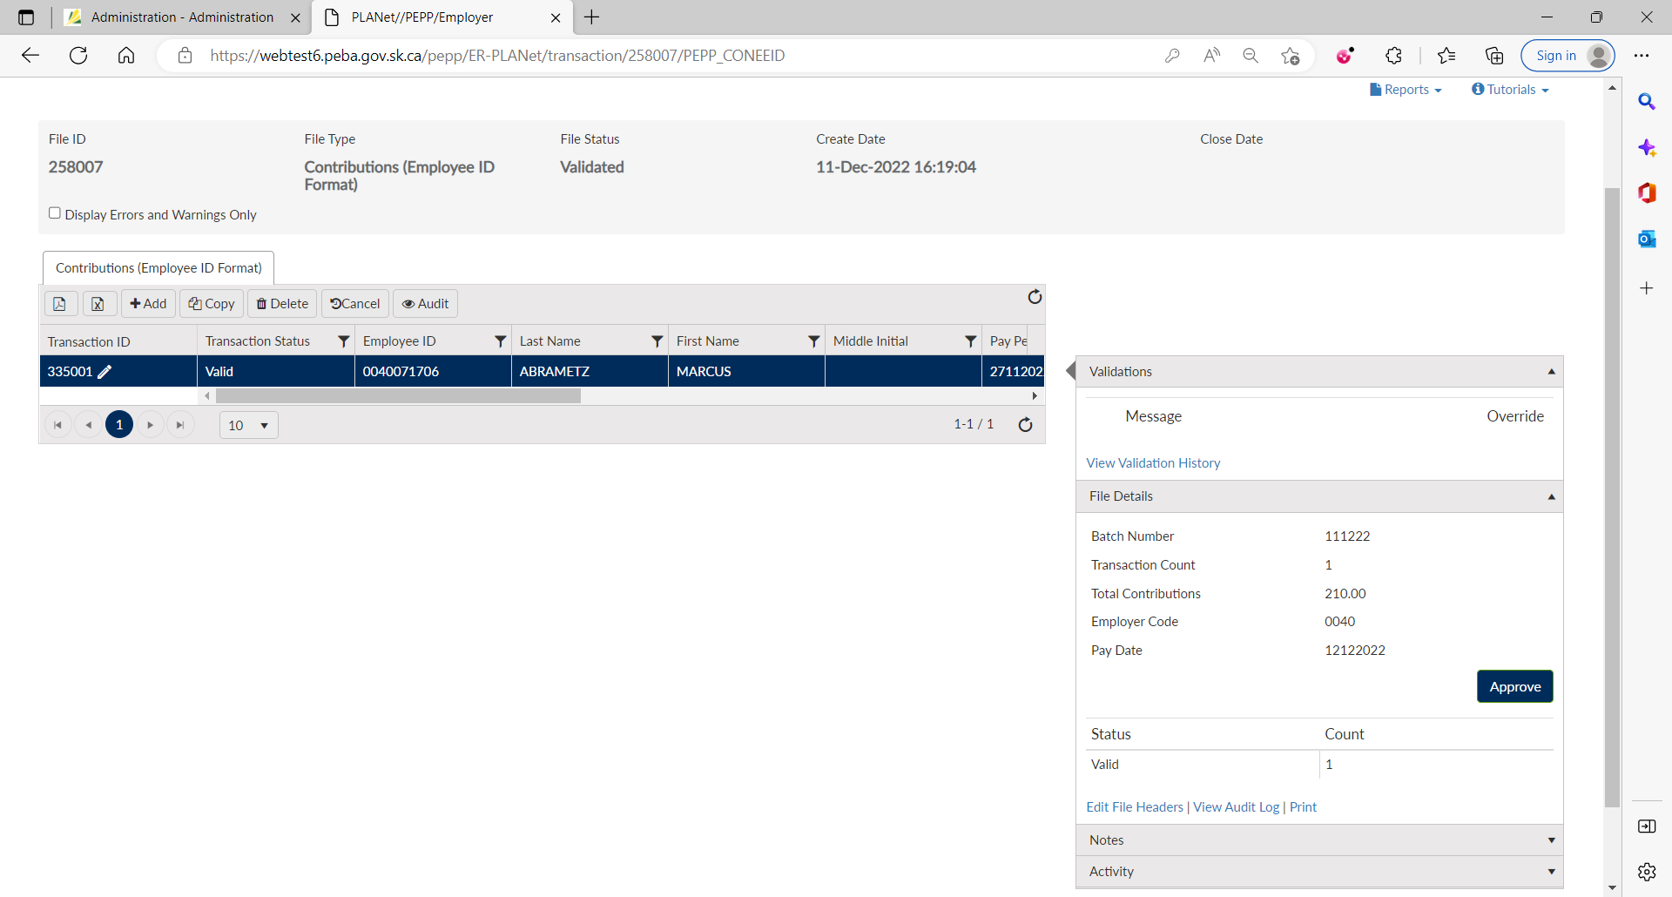

1. Now, you can see Approved On and Approved By as it has been approved. Click on Process.

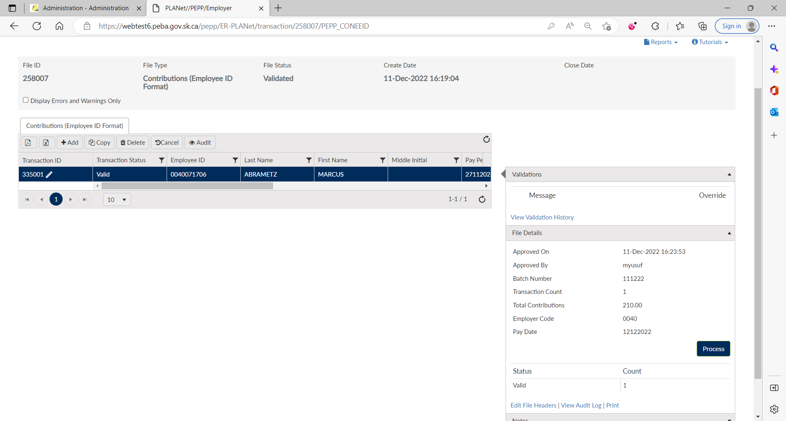

1. Now, you can see Processed On and Processed By as it has been processed.

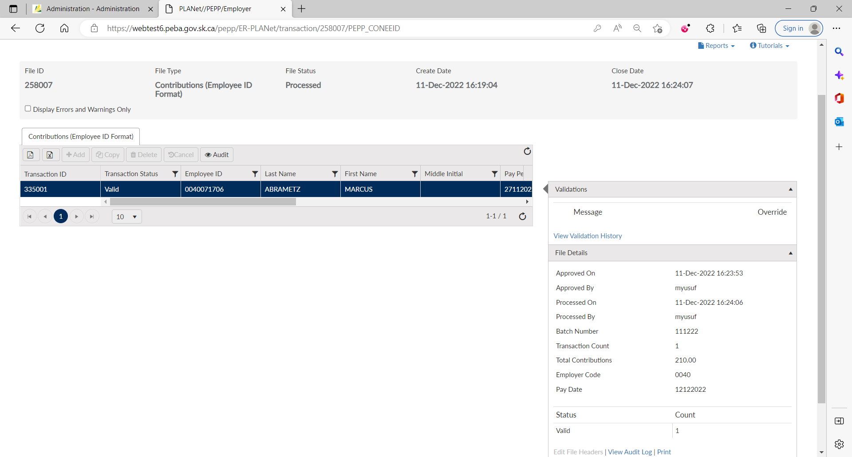

1. File status is now Processed.

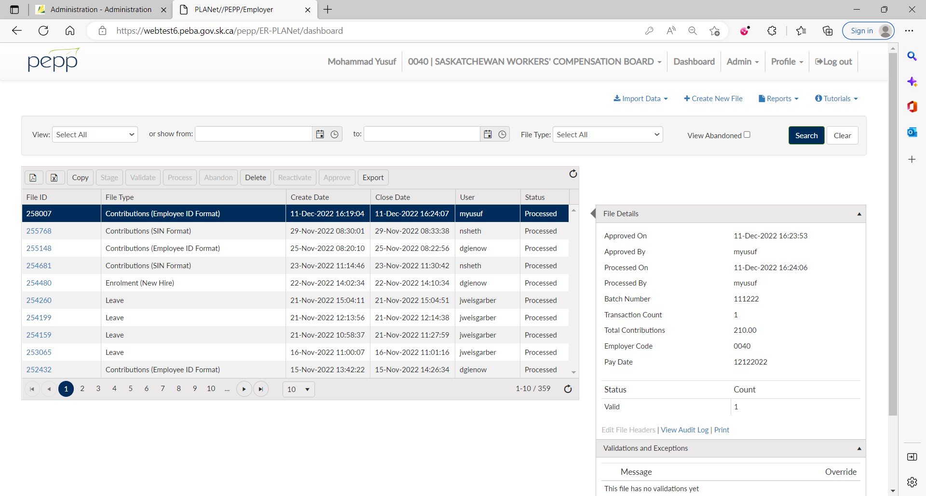

1. Log into Penfax and got to Batches -> Data Posting Batches.

Search with the employer. You can see the Contribution file you just processed through DCT.

Click on the Data Posting Batch ID and Go to Pending tab.

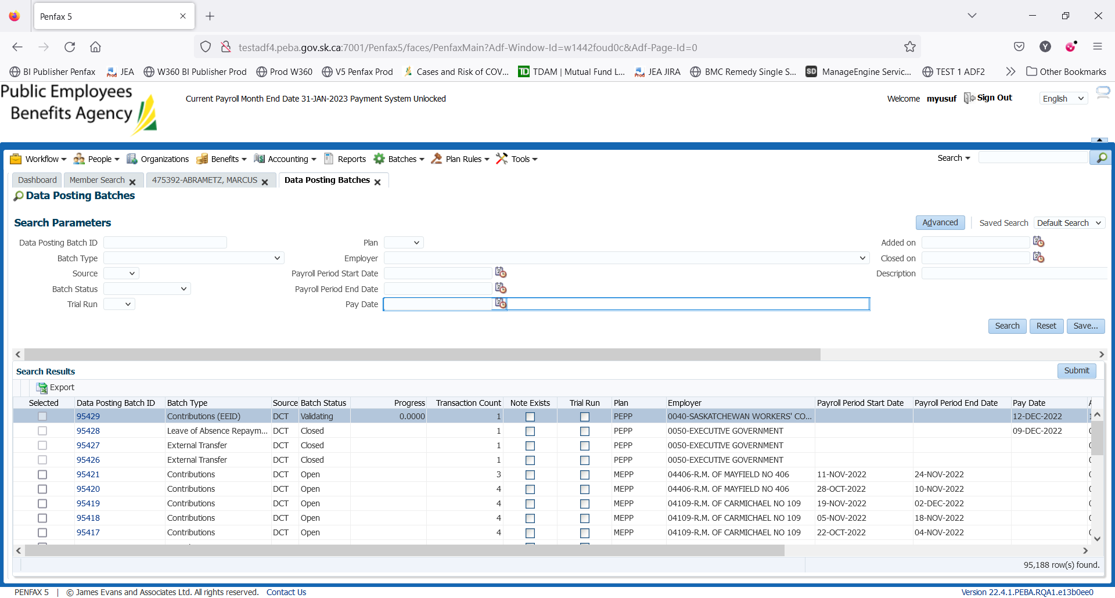

1. System triggers 3 errors – 1 for PEPP Receipt Date and 2 for remittance.

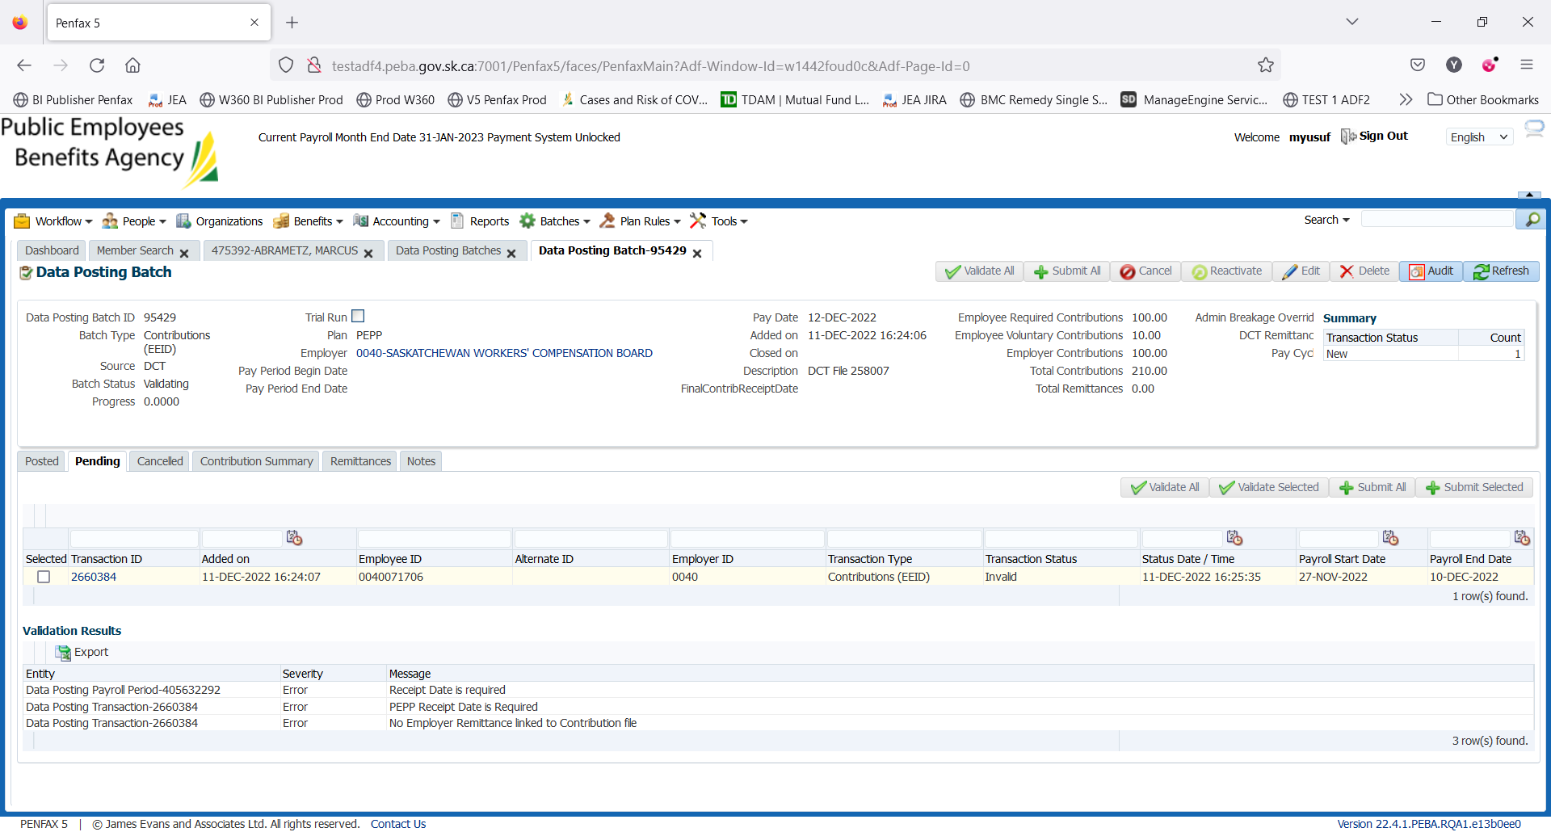

1. Go to Remittances tab and click Add to link the remittance to the data posting batch.

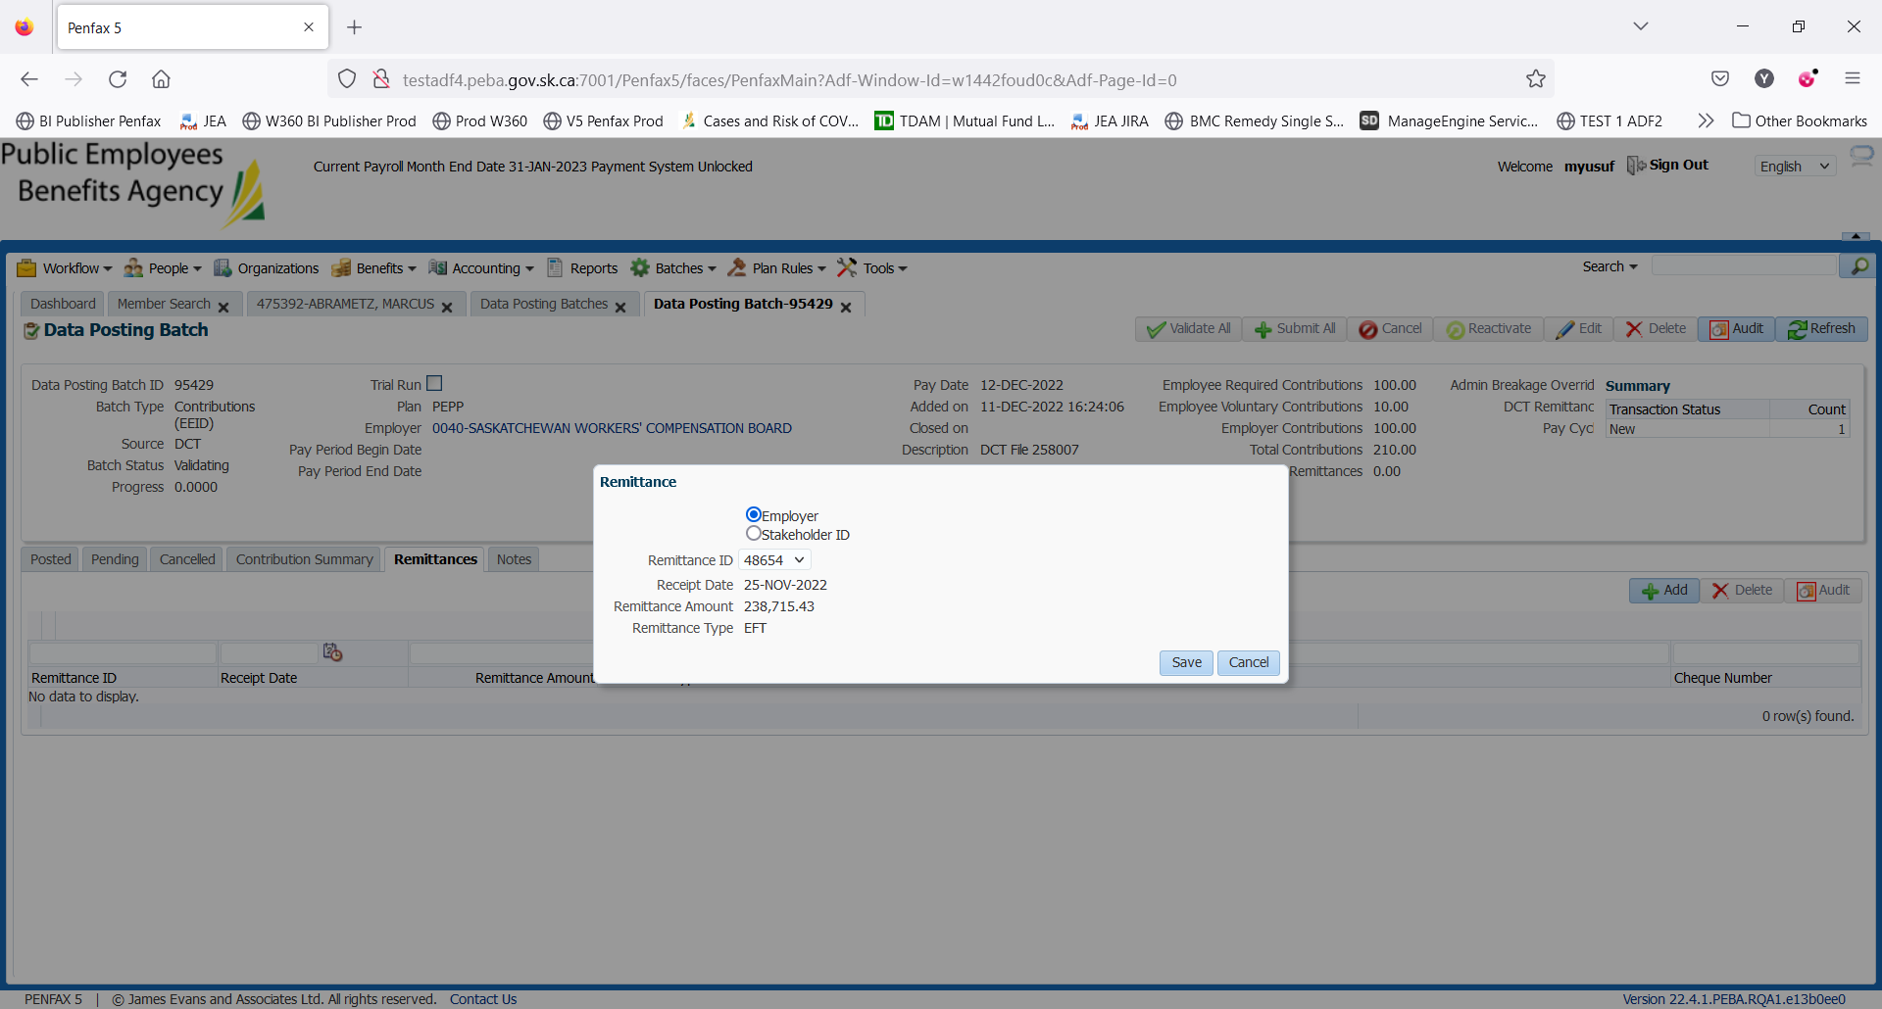

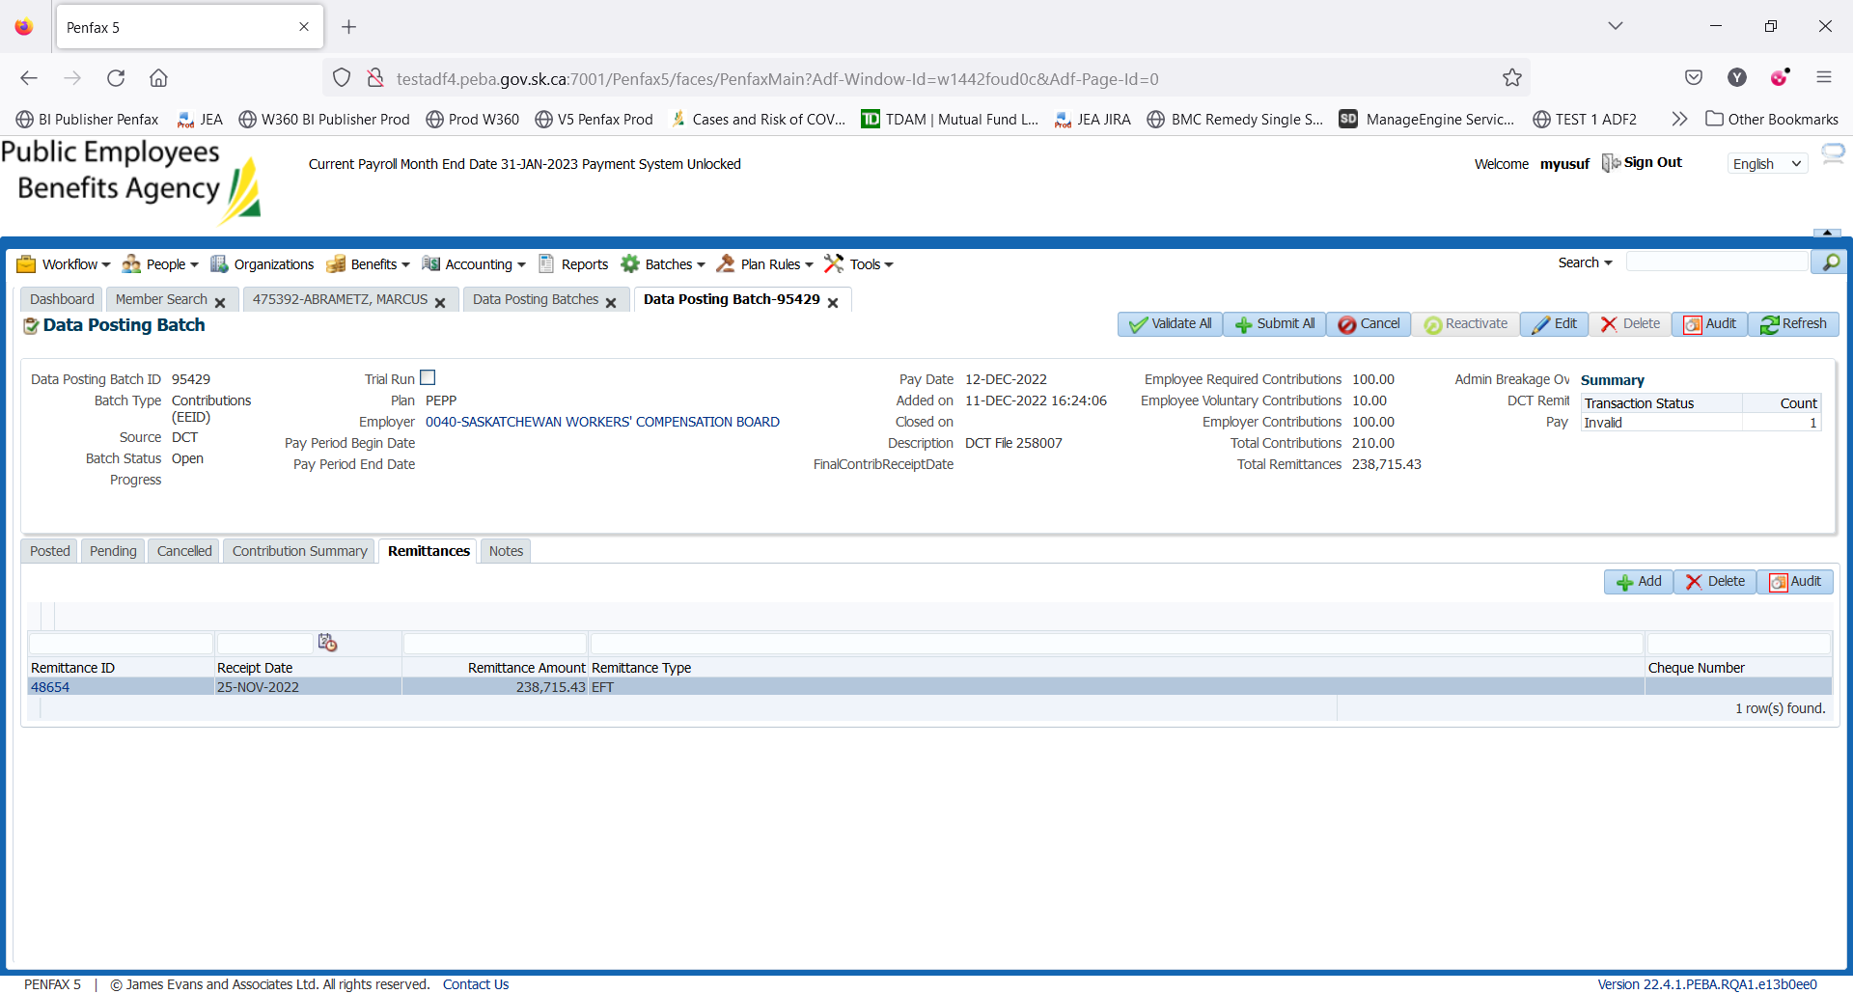

1. Click Edit on the top and add PEPP Receipt Date.

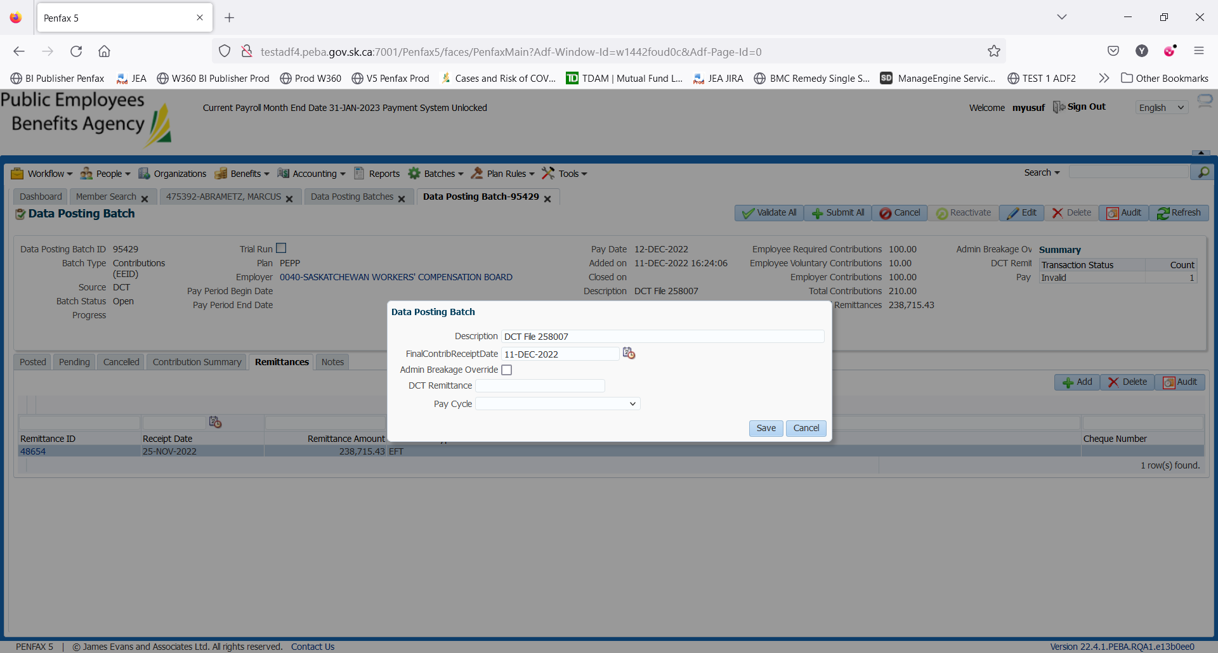

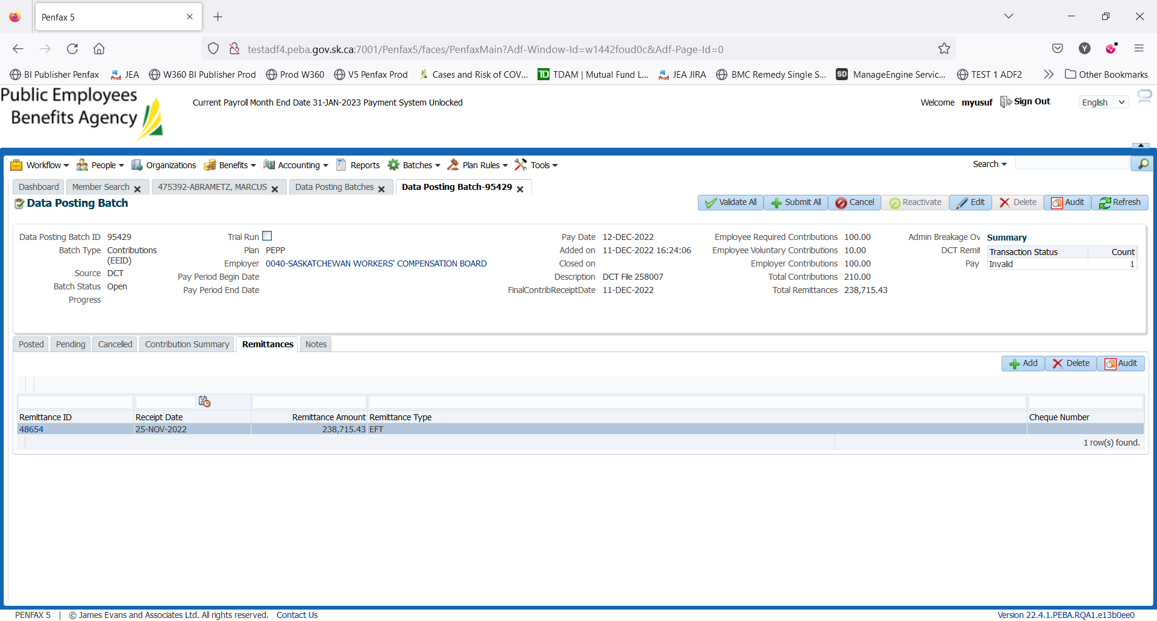

1. Now, go to Pending tab and validate all the transaction records by clicking on Validate All.

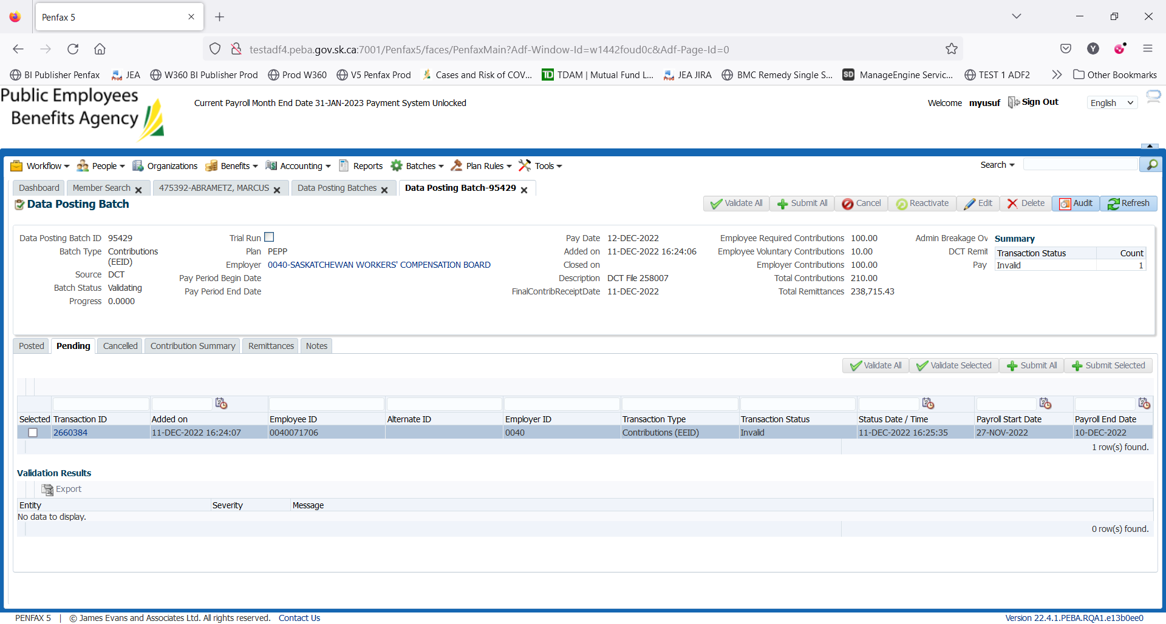

1. Now, submit all the transaction records by clicking on Submit All.

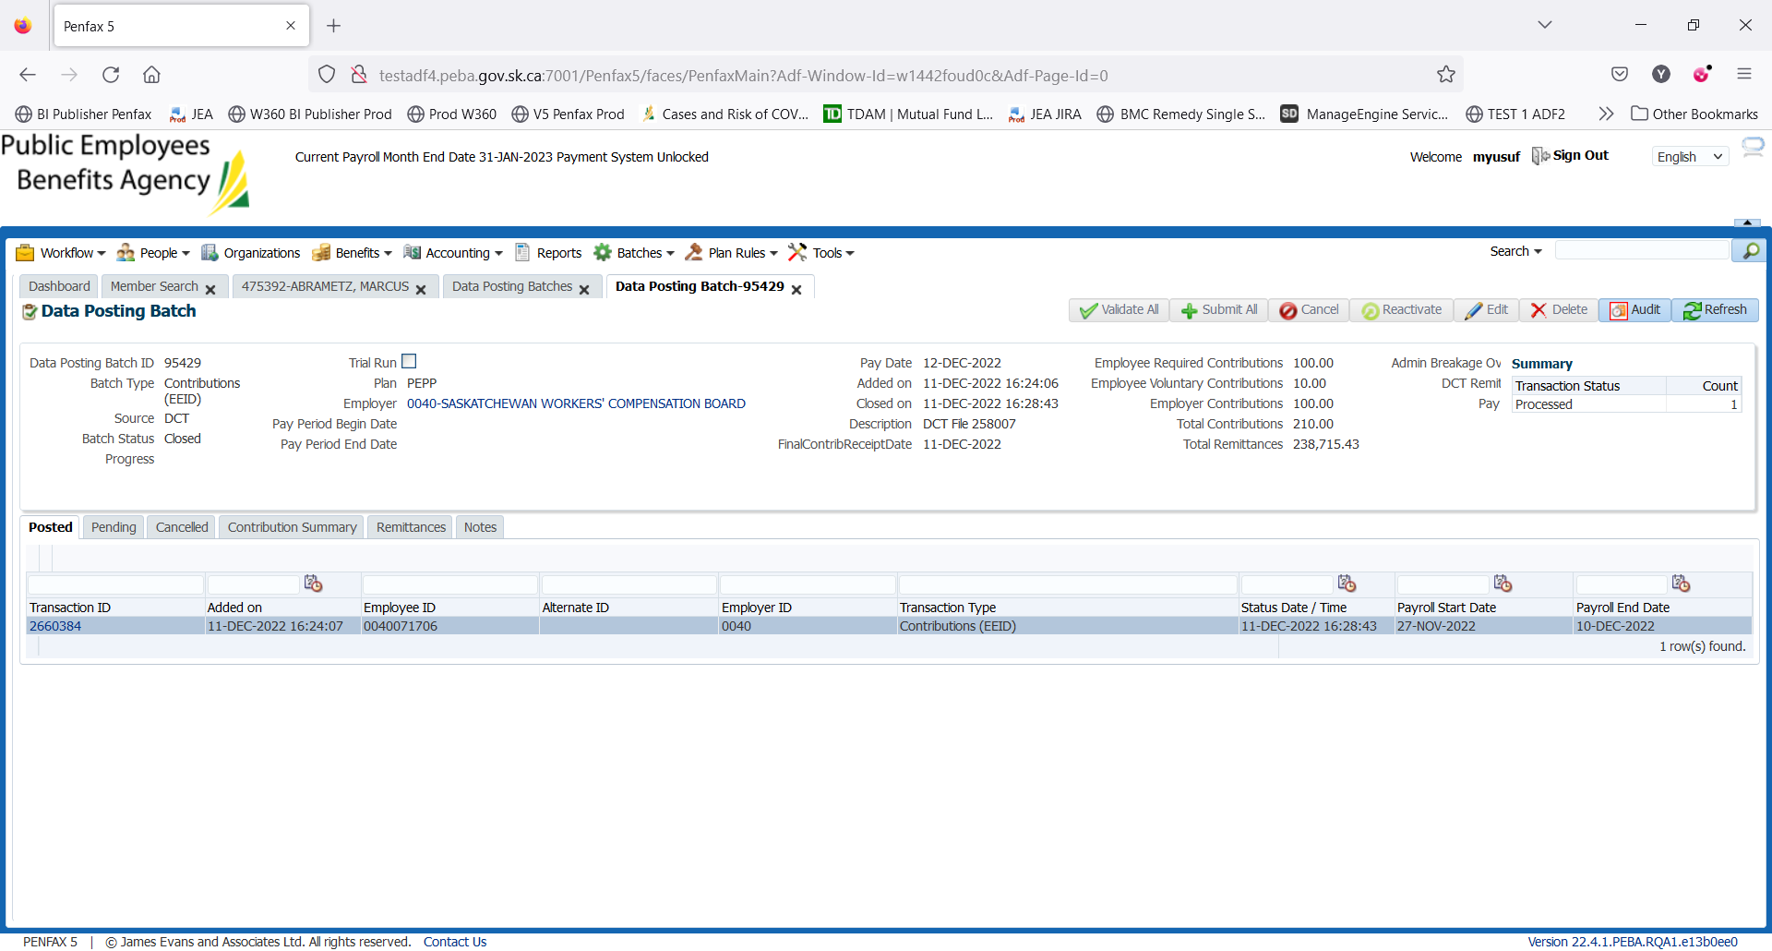

1. Records have been posted and so can be found under Posted tab now.



1. Bring up the members for whom contributions have posted. Go to Member Profile -> Contribution History. Contribution has been posted to member’s account.

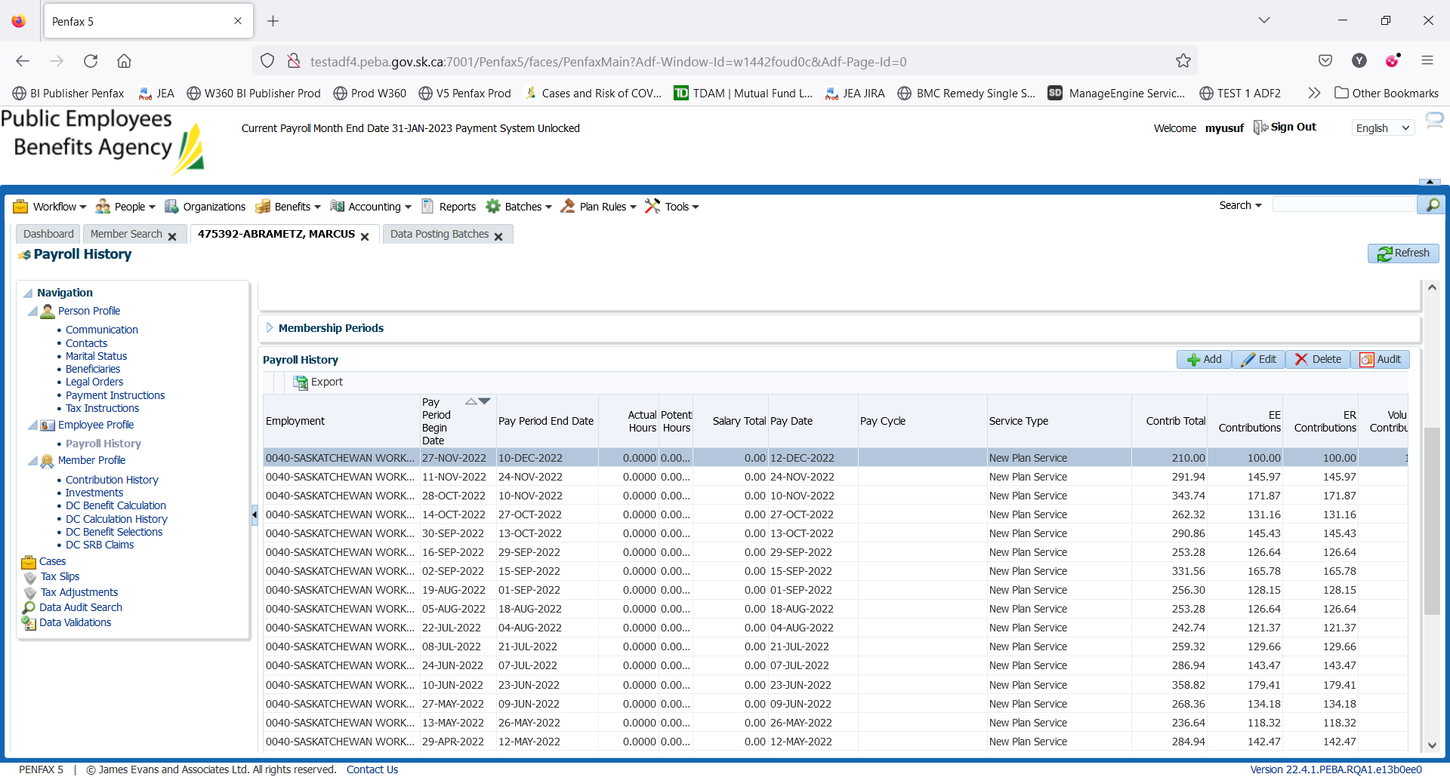

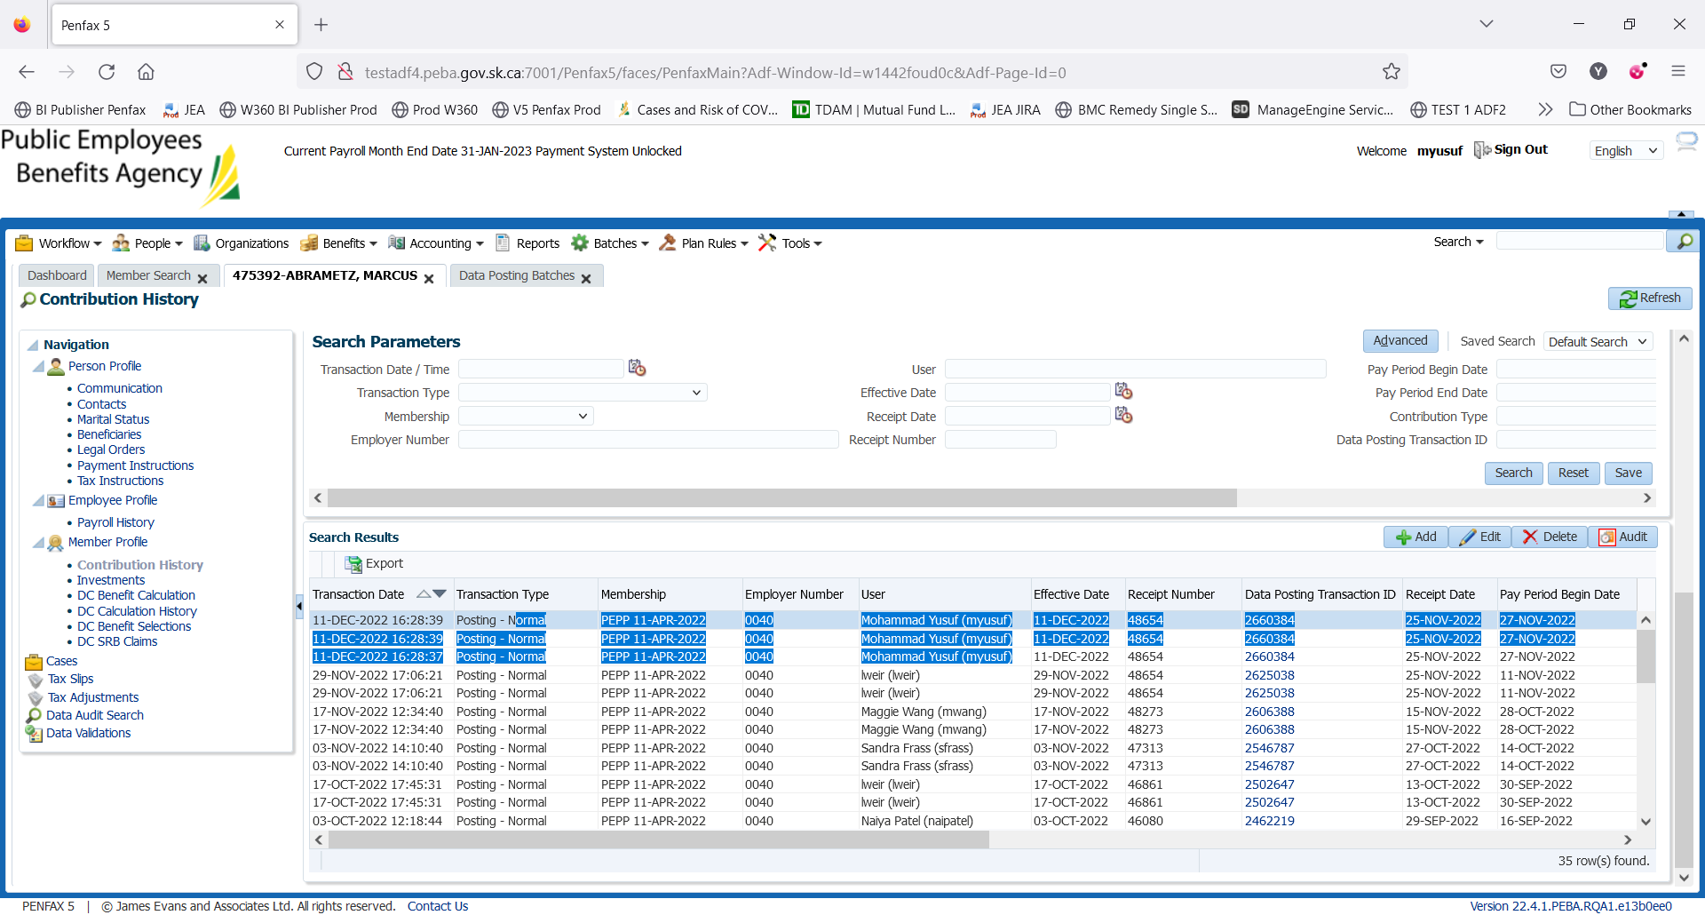

1. Go to Payroll History where you can find the posted contribution amount.

DAY 2

1. Wait for the PIT batch to run overnight.
2. Bring up a member in Penfax and go to Investments. Yesterday’s processed contribution can be seen under Account Activity.

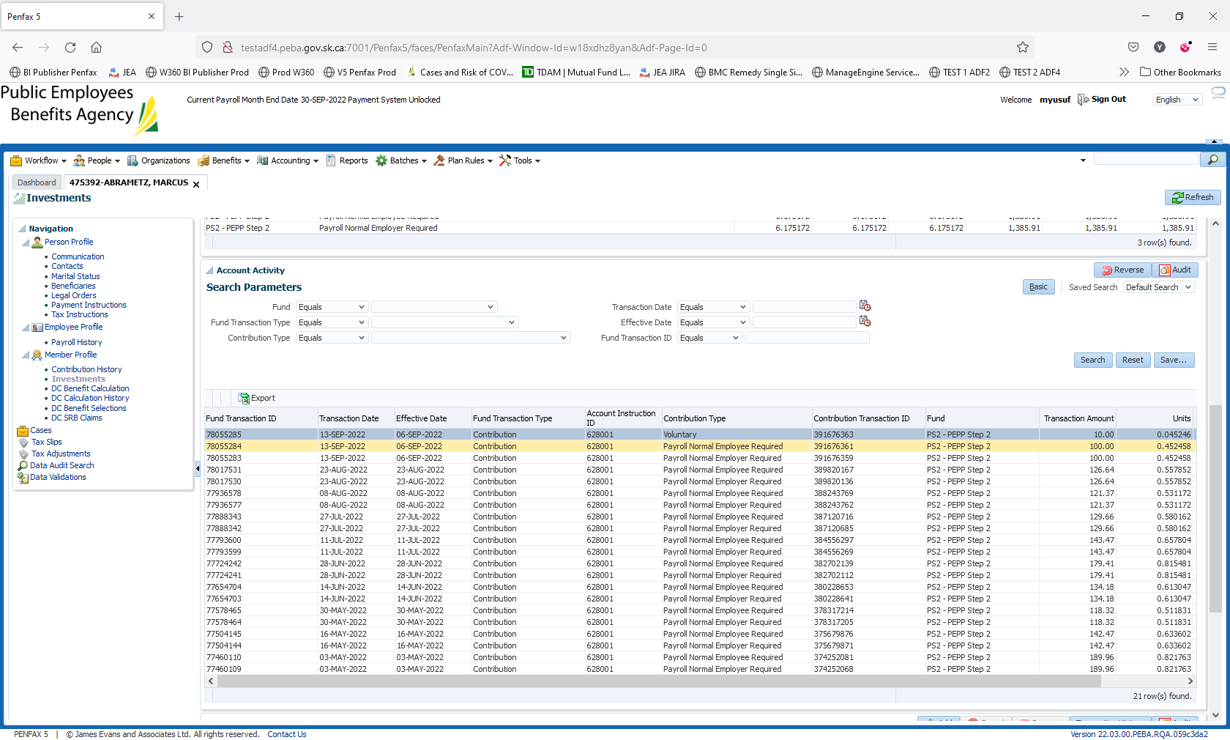

1. Go to Batches -> Batch Processes. Search for PEPP Valuation Report and open the first one.

For SID: 475392, $300 contribution posted into PS2 and for SID: 444179, $210 contribution posted in PS5 under the employer SASKATCHEWAN WORKERS' COMPENSATION BOARD that can be seen on Section Two tab.

